**INTRODUCTION**

Computers have become part of the life for accessing almost any kind of information. Life in the 21st century is full of technological advancement and in this technological age it is very difficult for any organization to survive without utilizing technology. The World Wide Web contributes greatly to the creation of an ever-increasing global information database. It could also be used as a mechanism to share information within an enterprise.

In today’s age of fast food and take-out, many restaurants have chosen to focus on quick preparation and speedy delivery of orders rather than offering a rich dining experience. Until very recently, all of these delivery orders were placed over the phone, but there are many disadvantages to this system, including the inconvenience of the customer needing to have a physical copy of the menu, lack of a visual confirmation that the order was placed correctly, and the necessity for the restaurant to have an employee answering the phone and taking orders.

What I propose is an online ordering system, which is a technique of ordering foods online applicable in any food delivery industry. The main advantage of my system is that it greatly simplifies the ordering process for both the customer and the restaurant. When the customer visits the ordering webpage, they are presented with an interactive and up-to-date menu, complete with all available options and dynamically adjusting prices based on the selected options. After making a selection, the item is then added to their order, which the customer can review the details of at any time before checking out. This provides instant visual confirmation of what was selected and ensures that items in the order are, in fact, what was intended.

This system also greatly lightens the load on the restaurant’s end, as the entire process of taking orders is automated. Once an order is placed on the webpage, it is entered into the database and then retrieved, in pretty much real-time, by a desktop application on the restaurant’s end. Within this application, all items in the order are displayed, along with their corresponding options and delivery details, in a concise and easy to read manner. This allows restaurant employees to quickly go through the orders as they are placed and produce the necessary items with minimal delay and confusion.

**Problem statement**

The challenges encountered by the existing system serve as a major drawback to the realization of efficiency and customer satisfaction. The experience of ordering in most fast food restaurants is not pleasant for the customers. Customers will have to make long queues before placing their orders especially during peak hours and then the ordering staff will record customer orders. Having placed their order, the customer must then wait near the counter until their order is ready for collection. The other problem in the food service industry is that restaurants are not realizing the efficiencies that would result from better application of technology in their daily operations. Fast food business in a very competitive business and one way to stand out from competitors is through improving the business process where business process automation can assist business improvement. The other problem with the current system is that the customers are not able to see the ingredients of the meals before they place their order and also they only have to pay for an order online.

**Objectives**

**General objectives**

* To increase efficiency and improve services provided to the customers through better application of technology in daily operations.
* To be able to stand out from competitors in the food service industry

**Specific objectives**

* To enable customers to order custom meals that aren’t in the menu
* To enable customers to have a visual confirmation that the order was placed correctly
* To enable customers to know food ingredients before ordering
* To reduce restaurant’s food wastage
* To ensure correct placement of orders through visual confirmation
* Improve efficiency of restaurant’s staff
* Eliminate paper work and increase level of accuracy
* Increase speed of service, sales volume and customer satisfaction

**Justification**

* To increase efficiency by shortening the purchasing time and eliminating paper work like receipts through online transaction
* To be able to stand out from competitors by automating daily operations which will give food service providers the opportunity to increase sales
* To reduce restaurants food wastage and increasing efficiency of the restaurants staff by enabling the restaurants staff to know what food items the customers want in advance.
* To increase customer satisfaction by speeding up food delivery
* To reduce time wasting by eliminating long queues

**Project scope**

Online ordering system will be a web based application whose main language of programming will be PHP. Its main aim is to simplify and improve the efficiency of the ordering process for both customer and restaurant, minimize manual data entry and ensure data accuracy and security during order placement process. Customers will also be able to view product menus and there ingredients and be able to have a visual confirmation that the order was place correctly.

**Limitation of the system**

* Requires internet connection and also the user must be computer literate.
* The set back of the system is that the customers targeted are adults with access to computer systems while the minors might have to go physically to the restaurant to purchase the food that they want or order food the food with the help of an adult.
* The other limitation is that the system will only be convenient to people with a small geographical region, basically just around the restaurant i.e. can only help a small area.

**LITERATURE REVIEW**

**METHODOLOGY**

Weaknesses of the current system

* Inconvenience of customer needing to have a physical copy of the menu
* Time consuming
* Lack of visual confirmation that the order was placed correctly
* Necessity for restaurant to have an employee answering the phone and taking orders
* Difficulty in tracking customers past history
* Manual work and consumes large volumes of data
* Lack of data security

**Merits of the proposed system**

* Security of data. Data are well protected for personal use.
* Ensures data accuracy during order placement process
* Minimized manual data entry
* Greater efficiency since data processing is very fast
* User friendly and interactive interface with provision for customer to view menus and have a visual confirmation that the order was place correctly.
* Minimized time requirement during the order placement process
* Greatly simplifies the ordering process for both customer and restaurant.

**Feasibility study**

This is an evaluation and analysis of the potential of the proposed project which is based on extensive investigation and research to support the process of decision making. It assesses the operational, technical and economic merits of the proposed project. The feasibility study is intended to be a preliminary review of the facts to see if it is worthy of proceeding to the analysis phase. From the systems analyst perspective, the feasibility analysis is the primary tool for recommending whether to proceed to the next phase or to discontinue the project.

**Technical feasibility**

This assessment is focused on gaining an understanding of the present technical resources of the organization and their applicability to the expected needs of the proposed system. It is an evaluation of the hardware and software and how it meets the needs of the proposed system. The systems project is considered technically feasible if the internal technical capability is sufficient to support the project requirements. The essential questions that help in testing the technical feasibility of a system include the following:

* Is the project feasible within the limits of current technology?
* Does the technology exist at all?
* Is it available within given resource constraints?
* Is it a practical proposition?
* Is there enough manpower- programmers, testers & debuggers?
* Do the required software and hardware exist?
* Are the current technical resources sufficient for the new system?
* Can they be upgraded to provide the level of technology necessary for the new system?
* Do we possess the necessary technical expertise, and is the schedule reasonable?
* Can the technology be easily applied to current problems?
* Does the technology have the capacity to handle the solution?
* Do we currently possess the necessary technology?

**Operational feasibility**

Operational feasibility is the measure of how well the project will support the customer and the service provider during the operational phase. It is dependent on human resources available for the project and involves projecting whether the system will be used if it is developed and implemented. The essential questions that help in testing the technical feasibility of a system include the following:

* Is the project feasible to operate or not?
* Does current mode of operation provide adequate throughput and response time?
* Could there be a reduction in cost and or an increase in benefits?
* Does current mode of operation offer effective controls to protect against fraud and to guarantee accuracy and security of data and information?
* Does current mode of operation make maximum use of available resources, including people, time, and flow of forms?
* Are the current work practices and procedures adequate to support the new system?
* If the system is developed, will it be used?
* Does it agree with the government regulations
* Will the proposed system really benefit the organization?
* Will the system affect the customers in considerable way?
* How do the end-users feel about their role in the new system?
* How will the working environment of the end-user change?

**Economic feasibility**

This assessment aims to determine the positive economic benefits to the organization that the proposed system will provide. It typically involves a cost/ benefits analysis and it’s the most frequently used method for evaluating the effectiveness of a new proposed system. Possible questions raised in economic analysis are:

* Is the system cost effective?
* Do benefits outweigh costs?
* The cost of doing full system study
* The cost of business employee time
* Estimated cost of hardware
* Estimated cost of software/software development
* Is the project possible, given the resource constraints?
* What are the savings that will result from the system?
* Cost of employees' time for study
* Cost of packaged software/software development
* Selection among alternative financing arrangements (rent/lease/purchase)

**Schedule feasibility**

It is the measure of how reasonable the project time table is or the deadline is reasonable or not. During the lack of time or the time become mandatory, we must finish the project within a given time period. It mainly addresses:

Can the project really be completed in the given period of time

**ANALYSIS AND DESIGN**

Development of computerized systems requires analysis of the process to be digitized in order to enable a correct system, a system that functions as required and to assist the potential users of the system understand the general functionality of the system. The analysis specifies the system's objectives and constraints to which designers have to comply. The purpose of doing analysis is to transform the system’s major inputs into structured specification.

**Context diagram**

This is a brief structure which depicts the environment in which a software system exists and helps in communicating about what lies outside the system boundary.

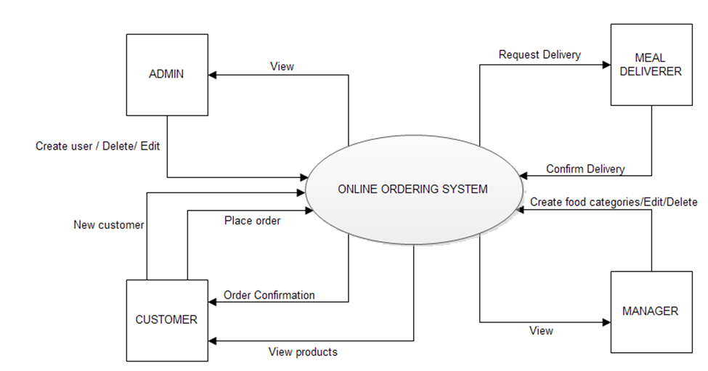

Figure -1

Data flow diagram

It is a two-dimensional diagram that explains how data is processed and transferred in a system. The graphical depiction identifies each source of data and how it interacts with other data sources to reach a common output.

**Administrator module**

Functionalities provided:

* Create usernames and passwords
* View/ edit / delete user accounts

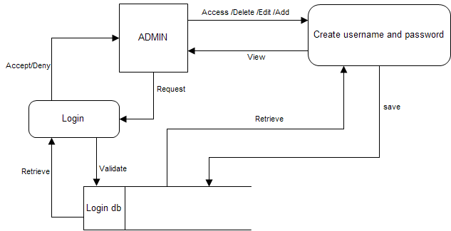

Figure -2

**Customer module**

Functionalities provided:

* View product’s list
* Register
* Place orders

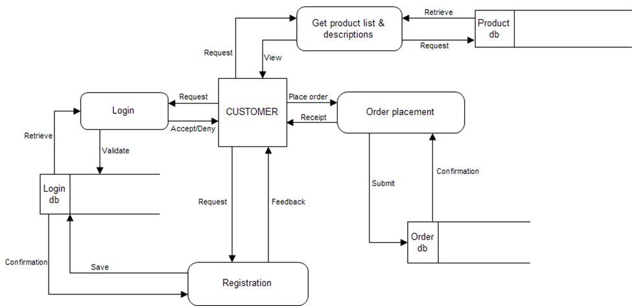

Figure -2.1

**Manager module**

Functionalities provided:

* Create product categories and functionalities
* Edit / delete product categories and descriptions
* View and manage orders and sales report

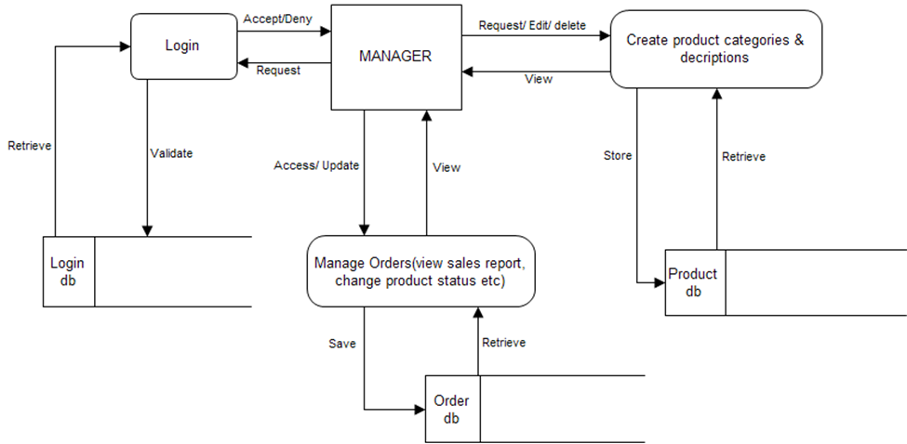

Figure -3

**Meal deliver module**

Functionalities provided:

* View pending orders and delivery details
* Confirm order deliveries

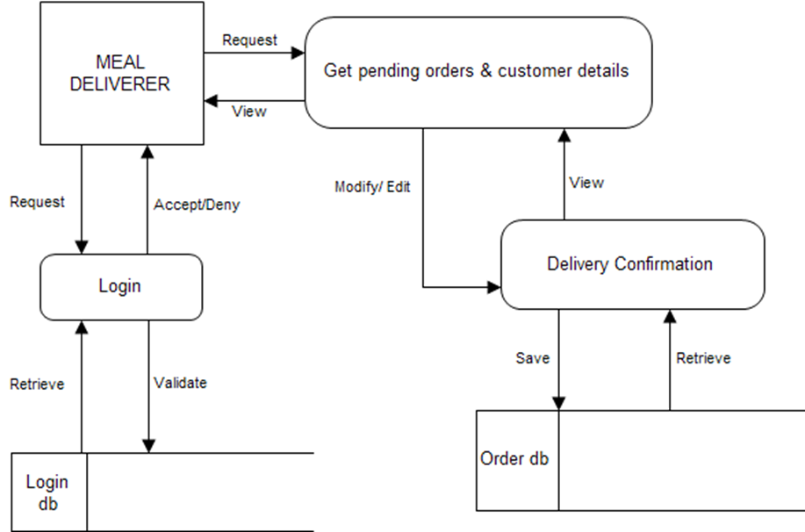

Figure -4

**User requirements**

The system will be designed to be user friendly. The user friendly and interactive interfaces design helps to achieve this by enabling customers to easily browse through the menus place orders with just a few clicks and also allows restaurant employees to quickly go through the orders as they are placed and produce the necessary items with minimal delay and confusion. The system will be simple to use.

**Functional requirements**

Functional requirements define the capabilities and functions that a system must be able to perform successfully. The functional requirements of this online ordering system include:

* The system shall enable the customer to view the products menu, create an account, login to the system and place an order.
* The customer shall specify whether the order is to be picked up or delivered.
* The system shall display the food items ordered, the individual food item prices and the payment amount calculated.
* The system shall prompt customer to confirm the meal order.
* The system shall provide visual confirmation of the order placement
* The system shall enable the manager to view, create, edit and delete food category and descriptions
* The system shall allow confirmation of pending orders.
* The system shall allow generation of sales report for the orders made.
* The system shall allow the manager to update additional information (description, photo, ingredients etc.) for a given food item.
* The system shall allow the manager to update price for a given food item.

**Non-functional requirements**

A non-functional requirement is a requirement that specifies criteria that can be used to judge the operation of a system, rather than specific behaviors. Some of the non-functional requirements include:

* They should be sufficient network bandwidth
* Backup- provision for data backup
* Maintainability- easy to maintain
* Performance/ response time- fast response
* Usability by target user community- easy to use
* Expandability- needs to be future proof or upgradable
* Safety- should be safe to use

**System requirements**

These consist of the hardware and software components of a computer system that are required to install in order to use the software efficiently.

Software requirements

* Operating system: Windows XP / windows 7
* Technology :PHP
* Database : MySQL
* Tool :Dreamweaver
* Antivirus software
* Backup & Data Recovery software

**Hardware requirements**

* **Processor:** Intel dual core or above
* **Processor Speed:**1.0GHZ or above
* **RAM:** 1 GB RAM or above
* **Hard Disk:** 20 GB hard disk or above
* Printer for printingreports
* Uninterruptible power supply to ensure a constant access of data.
* USB flash disk( At least 2GB)

**PLANNING**

Time scheduling

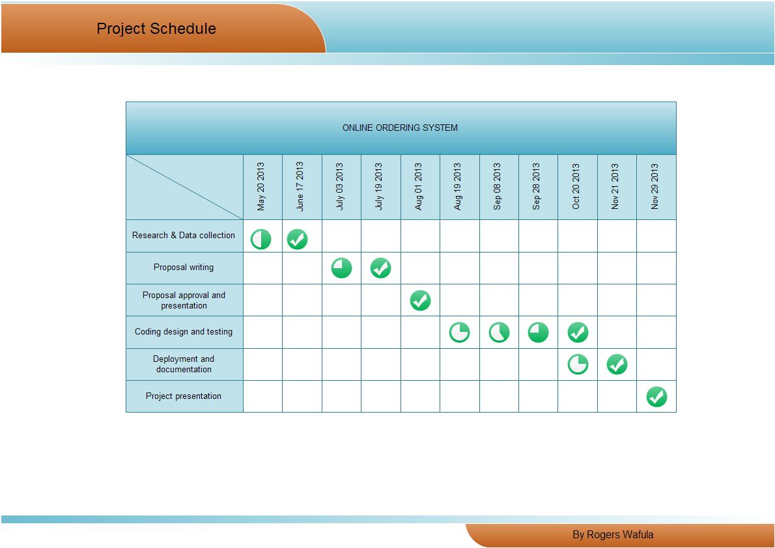

Figure -5

**Process model**

For my project I plan to use waterfall as a process model. The waterfall model is a sequential design process, often used in software development processes, in which progress is seen as flowing steadily downwards (like a waterfall) through the phases of Conception, Initiation, Analysis, Design, Construction, Testing and Maintenance.

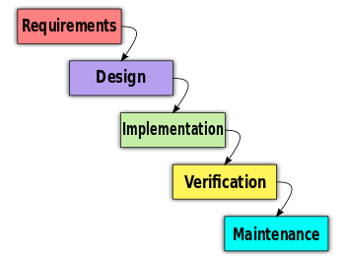

Figure -6

**LITERATURE SURVEY  
 RESEARCH METHODOLOGY**

Research methodology has many research dimensions and methods. The scope of research methodology is wider than research method. This is mainly adopted by the researcher in undertaking this research. Methodology is the underlying principles and rules that govern a system method, on the other hand it is a systematic procedure for a set of activities. Thus, from these definitions a methodology encompasses the methods used within a study.

A waterfall model under the software development life cycle (SDLC) is the methodology used to produce the online food ordering system and the customer self ordering system. It is used by system developers to produce or alter information systems or software.

It divides the development process into several stages or processes. After the completion of one stage, it will logically move to another stage. Sometimes moving back to the previous stage is necessary due to failure that occurs in current stage.

System design methods are a discipline within the software development industry which seeks to provide a framework for activity and the capture, storage, transformation and dissemination of information so as to enable the economic development of computer systems that are fit for purpose.

**METHODS OF DATA COLLECTION**

Although there are various methods of data collection, the researcher chose the two main sources of data collection in carrying out their study. They are:

1**. Primary source**

The primary source refers to the sources of collecting original data in which the researcher made use of empirical approach such as personal interview.

2**. Secondary source**

The secondary sources of data for this kind of project cannot be over emphasized. The secondary data were obtained by the researcher from magazines, journals, newspapers and library source.

**ORAL INTERVIEW**

The interview method of data collection can be defined as a systematic way of collecting data or information from a respondent through asking questions directly from the respondent and also collecting information with the aim of facilitating understanding. The oral interview was done between the researcher and the management of staff of KRISPY FAST FOOD, Awka. Reliable facts were gotten based on the questions posed to the staff by the researcher which help the researcher in starting the work and also helped in the area of solution presentation of the new design.

**STUDY OF MANUALS**

Manuals and report based on fast food services were obtained and studied and a lot of information concerning the system to be produced was obtained.

**EVALUATION OF FORMS**

Some forms that are necessary and available were accessed. These includes the restaurant menu fast food order form, payment receipts etc. these forms helped in the design of the new system.

**ANALYSIS OF EXISTING SYSTEM**

Throughout the system analysis, an in-depth, study of end-user information is conducted, for producing functional requirement of the proposed system. Data about the existing ordering system is collected through several fact-finding techniques such as website visit and document review, at the beginning of this stage. The data collected facilities information required during detailed analysis. A study on the current system is performed based on the collected data. As a result, user requirement of the proposed system are determined. At the end of this stage, requirement specification is produced as deliverable.

**THE EXISTING SYSTEM**

The existing system happens to be a non computerized operating system were all operations are done manually by the waiter carrying paper and to take down the order of the customer or making an order over the counter. This leads to mistakes because the waiter might not understand what the customer had ordered therefore serving him/her a different menu. This could be so embarrassing because the customer might not take it lightly with the waiter which may lead to misunderstanding.

**PROBLEMS OF EXISTING SYSTEM**

Due to manual means being employed by the fast food restaurants, it is very difficult to satisfy the wants and needs of the customers. Most of the problems include:

1. Mistakes are made when taking the orders of the customers
2. The process of collecting customers’ purchases order is very tedious.
3. This makes it impossible to deliver goods on time.
4. It leads to lack of understanding between the customers and the employees.
5. The record keeping system is poor. Losses of vital records have been reported in the past consequently. Besides, protecting the file system from unauthorized access is a problem that has defiled solution.
6. Unnecessary time is wasted conveying information through the ladder of authority. Management at times seeks to get a copy of the customer’s order form and this may take a lot of time to obtain it.
7. It causes reduction of production flow.

These are the major problems facing the existing system and would be corrected with the help of the proposed system.

**OBJECTIVES OF THE PROPOSED SYSTEM**

The proposed system is developed to manage ordering activities in fast food restaurant. It helps to record customer submitted orders. The system should cover the following functions in order to support the restaurant’s business process for achieving the objectives:

1. To allow the customer to make order, view order and make changes before submitting their order and allow them make payment through prepayment card or credit card or debit card.
2. To provide interface that allows promotion and menu.
3. To prevent interface that shows customers’ orders detail to front-end and kitchen staffs for delivering customers’ orders
4. Tools that generate reports that can be used for decision making
5. A tool that allows the management to modify the food information such as price, add a new menu and many others as well as tools for managing user, system menu and promotion records.

**JUSTIFICATION FOR THE NEW SYSTEM**.

It is the purpose of the new system to address all the problems plaguing the present system. This system will do the analyzing and storing of information either automatically or interactively. It will make use of PhP-MYSQL. This will be like this: a report is generated conforming to particular information needed by the management via the monitor. This will require the input of necessary data and record of fast food ordering and delivery and then a report is generated.

The proposed system will also have some other features such as:

1. Accuracy in handling of data
2. The volume of paper work will be greatly reduced.
3. Fast rate of operation as in making the ordered food available and delivered on time.
4. Flexibility (i.e. it can be accessed at any time)
5. Easy way to back up or duplicating data in CD’s in case of data loss
6. Better storage and faster retrieval system
7. Errors in the reports will be greatly minimized.

**SYSTEM DESIGN, IMPLEMENTATION AND TESTING DESIGN STANDARD**

The system is designed with several interaction cues on each web page that makes up the web application. These cues are well-defined such as to make several functionality that the application exposes to collect, process and output data. Access to these functionalities is made possible by the well designed user interface which embodies several technologies such as AJAX (Asynchronous JavaScript and XML) to process data. The application is built in a modular form where these functionalities are built into modules. Some of the modules are as follows:

1. Cart.php
2. Check_login.php
3. Inventory_details.php
4. Payments.php

**OUTPUT SPECIFICATION.**

The system is designed in such a way that it efficiently provides output to the user promptly and in a well organized manner. The format for the several output are make available on the output web pages. Output can be relayed using the following page modules:

1. Product_list.php: This display output information for the list of food delicacies which are currently available.
2. Search_result.php: This displays output information for the order report.

**INPUT SPECIFICATION.**

The system is designed to accept several input details efficiently through input forms and user clicks. The data captured through the user keystrokes and clicks are received by specific modules on the system and relayed to the back-end of the system for processing. Input is collected using the following page modules:

1. Index.php: This is used to capture preliminary user navigation information and preference information which gives the system a method of personalizing the page for the user on the next visit.
2. Admn_login.php: This is used to capture information about the administrative personnel who controls content and display on the system.

**DATABASE SPECIFICATION.**

The database system used to implement the back-end of the system is MySql. Access to the system was made possible by a graphical interface (phpMyadmin) with an ISAM engine. The database name is krispy and the structure of the data tables in the database are as follows:

1. Admin
2. Payment
3. Products

**ADMIN**

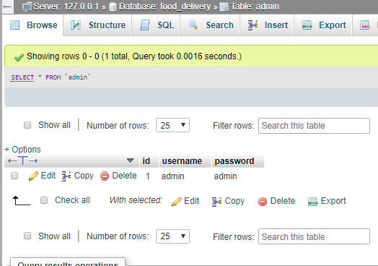

Figure -7

**PAYMENT**

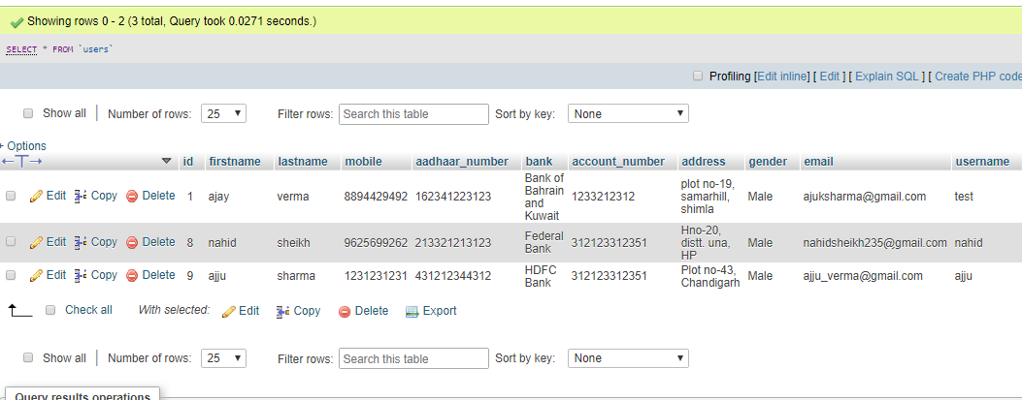

Figure -8

**PRODUCTS**

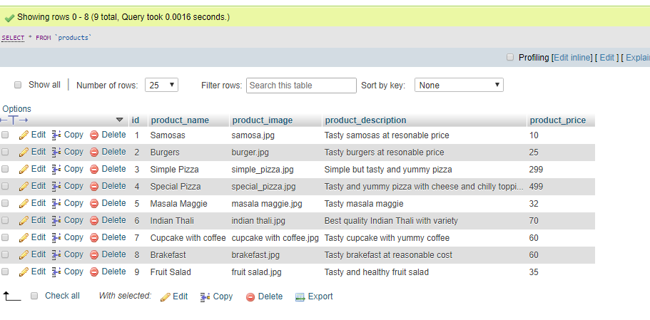

Figure -9

# Justification & Feasibility

## Justification

In today’s age of fast food and take-out, many restaurants have chosen to focus on quick preparation and speedy delivery of orders rather than offering a rich dining experience. Until very recently, all of these delivery orders were placed over the phone, but there are many disadvantages to this system. First, the customer must have a physical copy of the restaurant’s menu to look at while placing their order and this menu must be up to date. While this expectation is not unreasonable, it is certainly inconvenient.

Second, the orders are placed using strictly oral communication, which makes it far more difficult for the customer to receive immediate feedback on the order they have placed. This often leads to confusion and incorrect orders. The current system is also inconvenient for the restaurant itself, as they must either have a dedicated staff member to answer the phone and take orders, or some employees must perform double-duty, distracting them from their regular tasks.

What I propose is an online ordering system, originally designed for use in college cafeterias, but just as applicable in any food delivery industry. The main advantage of my system is that it greatly simplifies the ordering process for both the customer and the restaurant. When the customer visits the ordering webpage, they are presented with an interactive and up-to-date menu, complete with all available options and dynamically adjusting prices based on the selected options. After making a selection, the item is then added to their order, which the customer can review the details of at any time before checking out. This provides instant visual confirmation of what was selected and ensures that items in the order are, in fact, what was intended.

The system also greatly lightens the load on the restaurant’s end, as the entire process of taking orders is automated. Once an order is placed on the webpage, it is placed into the database and then retrieved, in pretty much real-time, by a desktop application on the restaurant’s end. Within this application, all items in the order are displayed, along with their corresponding options and delivery details, in a concise and easy to read manner. This allows restaurant employees to quickly go through the orders as they are placed and produce the necessary items with minimal delay and confusion.

While there are already a few systems like this in existence, all those I have encountered have been designed specifically for one restaurant, and thus cater only to their unique needs. Perhaps the greatest advantage of my system is its flexibility. The web order forms are built dynamically from the database, which can be managed using a graphical user interface. This allows the restaurant employees to not only set up and customize the system on their own, but also allows them to make changes to the menu in real time. For this reason, the exact same system can be used by numerous businesses with absolutely no modification to the code itself, which greatly increases its usefulness.

## Feasibility

At the present moment, the system is entirely functional, save the few minor bugs which are bound to present themselves during more extensive testing. A user is currently able to register and log in to the website and place an order. That order is then displayed, correctly and completely, in the order retrieval desktop application. Much of what is left to do focuses not on improving functionality, but rather on improving user experience by creating richer graphical interfaces for the user to interact with and modifying the application’s icons and color schemes to make them more pleasing to look at and use. For this reason, I feel that completing the project in the required timeframe is very feasible, particularly if I am able to adhere to the dates outlined in Figure 1, below.

In addition to time, a second factor influencing feasibility is resources, which also should not be a concern here. The online ordering system is structured like a fairly standard web application, and as such requires no special hardware and only basic software, namely web and database servers, to function properly. Therefore, I anticipate finishing all of the required work on time or, ideally, ahead of schedule, leaving me with time to investigate a few additional features I would like to add but are not integral to the system.

# Requirements Specification

## System Model

The structure of the system can be divided into three main logical components. The first component must provide some form of menu management, allowing the restaurant to control what can be ordered by customers. The second component is the web ordering system and provides the functionality for customers to place their order and supply all necessary details. The third and final logical component is the order retrieval system. Used by the restaurant to keep track of all orders which have been placed, this component takes care of retrieving and displaying order information, as well as updating orders which have already been processed.



Figure -9

## Functional Requirements

As can be seen in the system model diagramed above, each of the three system components essentially provides a layer of isolation between the end user and the database. The motivation behind this isolation is twofold. Firstly, allowing the end user to interact with the system through a rich interface provide a much more enjoyable user experience, particularly for the non-technical users which will account for the majority of the system’s users. In addition, this isolation layer also protects the integrity of the database by preventing users from taking any action outside those which the system is designed to handle. Because of this design pattern, it is essential to enumerate exactly which functions a user will be presented and these functions are outlined below, grouped by component.

### The Web Ordering System

Users of the web ordering system, namely restaurant customers, must be provided the following functionality:

* Create an account.
* Manage their account.
* Log in to the system.
* Navigate the restaurant’s menu.
* Select an item from the menu.
* Customize options for a selected item.
* Add an item to their current order.
* Review their current order.
* Remove an item/remove all items from their current order.
* Provide delivery and payment details.
* Place an order.
* Receive confirmation in the form of an order number.

As the goal of the system is to make the process of placing an order as simple as possible for the customer, the functionality provided through the web ordering system is restricted to that which most pertinent to accomplish the desired task. All of the functions outlined above, with the exceptions of account creation and management, will be used every time a customer places an order. By not including extraneous functions, I am moving towards my goal of simplifying the ordering process.

### Menu Management System

The menu management system will be available only to restaurant employees and will, as the name suggests, allow them to manage the menu that is displayed to users of the web ordering system. The functions afforded by the menu management system provide user with the ability to, using a graphical interface:

* Add a new/update/delete vendor to/from the menu.
* Add a new/update/delete food category to/from the menu.
* Add a new/update/delete food item to/from the menu.
* Add a new/update/delete option for a given food item.
* Update price for a given food item.
* Update default options for a given food item.
* Update additional information (description, photo, etc.) for a given food item.

It is anticipated that the functionality provided by this component will be one of the first things noted by the restaurant user, as they will have to go through it to configure their menu, etc. before beginning to actually take orders. Once everything is initially configured, however, this component will likely be the least used, as menu updates generally do not occur with great frequency.

### Order Retrieval System

Of the three components, the order retrieval system is functionally the simplest. Like the menu management system, it is designed to be used only by restaurant employees, and provides the following functions:

* Retrieve new orders from the database.
* Display the orders in an easily readable, graphical way.
* Mark an order as having been processed and remove it from the list of active orders.

## User Interface Specifications

Each of the system components will have their own unique interface. These are described below.

### Web Ordering System

Users of the web ordering system will interact with the application through a series of simple forms. Each category of food has its own form associated with it which presents a drop down menu for choosing which specific item from the category should be added to the order, and a series of check boxes and radio buttons for selecting which options are to be included. Adding an item to the order is accomplished by a single button click. Users select which category of food they would like to order, and therefore which form should be displayed, by navigating a menu bar, an approach which should be familiar to most users.

Entering delivery and payment deals is done in a similar manner. The user is presented with a form and must complete the required fields, which include both drop down and text boxes, before checking out and receiving a confirmation number. One thing worth noting here is that whenever possible drop down boxes and buttons were used over freeform input in order to both simplify the ordering process and reduce the possibility of and SQL injection attempt.

### Menu Management System

User interaction with the menu management system is similar to that with the web ordering system. Users navigate a tree structure to find the vendor, category, or specific food item that they would like to modify and after making their selection they are presented with a form which displays all of the current fields and values associated with that item, all of which can be modified or removed. The form also presents buttons which allow the addition of new fields and values. Unlike the web ordering system, however, most of the input here will be freeform, specifically in the form of text boxes, since there is no finite set of fields which could be added. This does not raise a major concern though, as input sanitation will be performed, and the user, who is assumed to be a restaurant employee, is less likely to be malicious than a web user.

### Order Retrieval System

User interaction with the order retrieval will be very simple. The application will automatically fetch new orders from the database at regular intervals and display the order numbers, along with delivery time, in a panel on the left hand side of the application. To view the details of an order, the user must simply click on that order number, which will populate the right-hand panel with the details, displayed in an easy to read and navigate tree structure. This structure can intuitively be expanded and collapsed to display only the desired information. Finally, once and order is processed, the user clicks a single button, labeled “Processed”, to remove it from the list of active orders.

## Non-functional Requirements

Because the design patterns of the Online Ordering System are pretty much the standard for a web application, the non-functional requirements of the system are very straightforward. Although written using Google Web Toolkit, the application is cross-compiled to HTML and JavaScript, along with a PHP backend, all of which are supported by any reasonably well maintained web server, although I would recommend Apache2, and particularly the free XAMPP distribution.

All of the application data is stored in a PostgreSQL database, and therefore a PostgreSQL server must also be installed on the host computer. As with Apache2, this software is freely available and can be installed and run under most operating systems.

The server hardware can be any computer capable of running both the web and database servers and handling the expected traffic. For a restaurant that is not expecting to see much web traffic, or possibly doing only a limited test run, an average personal computer may be appropriate. Once the site starts generating more hits, though, it will likely be necessary to upgrade to a dedicated host to ensure proper performance.

## System Evolution

As mentioned in the system model, at the heart of the entire ordering system is the database. In fact, the system could be completely operational using nothing but the database and an appropriate shell utility, assuming that all users are well-versed in SQL and enjoy using it to order food. While this would be a bit extreme, it does illustrate the point that the one part of the system which will stay relatively constant is the database. On the other hand, it is very probable that the other components will continue to evolve with time. For example, with the booming popularity of mobile applications, I would really like to make the web interface available as a phone application as well. Also it may make sense to at some point migrate the menu management and order retrieval systems to web, or even mobile, applications as well, as some users may prefer to use them as such.

I am also certain that if this system goes into actual use, many requests will arise for additional features which I had not previously considered, but would be useful to have. For this reason, I feel as though the application can be constantly evolving, which I consider a very good thing.

## SYSTEM DESIGN

### The Database & the 3 Components

The structure of the system can be divided into three main logical components. The first component must provide some form of menu management, allowing the restaurant to control what can be ordered by customers. The second component is the web ordering system and provides the functionality for customers to place their order and supply all necessary details. The third and final logical component is the order retrieval system. Used by the restaurant to keep track of all orders which have been placed, this component takes care of retrieving and displaying order information, as well as updating orders which have already been processed.



Figure -10

### Web Ordering System Components

The web ordering system is comprised of 6 major components. These are the login form, the main menu, the account management form, the order form, the shopping cart, and the checkout form. When the customer first arrives at the site, they are presented with the login form. After either signing in or, if they do not yet have an account, first registering and then signing in, the user is taken to a welcome page with the main menu. From here, they have two options – they can either change their password and other preferences through the account management form, or they can select an order form and begin adding items to their order. If they choose the second path, they can navigate the numerous order forms using the main menu, each of which corresponds to a specific category of order items, adding items to their shopping cart along the way. At any time they can view and modify their shopping cart and when they are finally ready to place their order, they can proceed to the checkout form. The checkout form uses the contents of the shopping cart to present a summary of the order and to calculate the total cost, in addition to allowing the user to specify all of the necessary delivery details.



#### 

Figure -11

#### The Login Form

The login form is standard for a form of this type. It provides text fields for username and password, which the user must enter before signing in. This form also gives the option for a user to register for the site if they have not yet done so.

#### The Main Menu

The main menu, found at the top of the screen like in most applications, presents the user with two levels of selections. They must first choose the vendor they would like to view and then choose a category of food. Once they make these two selections, the application generates an order form specifically for that type of food, and displays this form to the user.

#### The Account Management Form

Currently the account management form only offers the user the option to change their password.

#### The Order Form

The order form, which is dynamically generated based on selections from the main menu,

#### The Shopping Cart

The shopping cart performs much like a shopping cart in any other application. After an item is added to the order, it is displayed, along with its price, in the shopping cart. The shopping cart also keeps a running total of the current price of the whole order. By clicking on an item in the shopping cart, the user can review all of the details for that particular item. Finally, the shopping cart contains a button for the user to proceed to checkout.

#### The Checkout Form

The checkout form is the user’s last chance to verify that the contents of their order are correct before actually placing it. This form also provides fields for the user to supply all of the necessary checkout and delivery details (payment type, delivery address, etc.).

### Menu Management System Components

In order to make use of the menu management system, the user must interact with the navigation tree, which uses a hierarchical tree structure to display all of the vendors, categories of foods, and specific food items stored in the system. When the user selects an item from this tree, they are able to edit the item using the appropriate form – a Vendor Form if a vendor is selected, a Category Form if a category of foods is selected, and a Food Form if an individual food item is selected.

Figure -12



#### The Navigation Tree

The navigation tree is a 3-level (excluding the root) hierarchical arrangement, with each leaf corresponding to a form. At the first level are vendors, at level two categories of food, and at level 3 individual food items. When a leaf is selected, it brings up a form corresponding to the item at that leaf.

#### The Forms

There are three types of forms in the menu management system - Vendor Forms, Category Forms, and Food Forms. The three forms are all similar, allowing the user to add, edit, and remove information relevant to the selected item. Where they differ is in the specific fields that the user is able to edit. After changes to any of the forms are saved, the necessary records in the database are updated.

### Order Retrieval System Components

The simplest of the three components, the order retrieval system can be broken down into just two components. They are the summary panel, which displays a list of all currently active orders, and the order detail panel, which highlights just a single order. When the application first starts, the order details for the first order in the list are displayed. In order to view the details of a different order, the user must simply select it from the list in the summary panel.



Figure -13

### 

#### Summary Panel

The summary panel, located on the left side of the screen, displays a list of all currently active orders, along with their delivery times and statuses. By changing the selected item in this list, the user is able to control the contents of the order detail panel.

#### Order Detail Panel

The order detail panel which contains a hierarchical tree structure for viewing all of the details related to the order which is currently selected in the summary panel. This component also contains a button to mark the order as processed and remove it from the list of active orders.

## User Interface Design

The user interface design principles can be broken into two groups. The interface in the web application is designed to limit free form user input, using mostly drop down menus, radio buttons and check boxes. This is done for two reasons – to simplify the ordering process as much as possible, and to limit SQL injection attempts. Free form input is necessary in the menu management component, however, as all of the values must be user supplied. The interface for this component contains traditional forms comprised of text fields and corresponding labels, along with save and discard buttons for each form.

## Help System Design

Due to the form-based nature of the applications, the design of the help systems will be minimal. In both the desktop and web applications, it will be accessed from the application’s main menu and will open in a new window. Modeled after the typical help system design, it will be both searchable and include a navigation tree highlighting common topics. There will be a help page for each form type, describing the significance of each field on the page.

# Testing Design

## Testing

### Phases

The structure of the system can be divided into three main logical components, plus the database, which is invisible to the end user. Each of these components must be tested individually, and the approaches which will be used for each component are described in the following sections.



Figure -14

#### Database

Testing of the database component is very straightforward, and has actually already been mostly completed. The database was the first component designed and before beginning work on any of the applications, I wrote all of the SQL statements I expected to need and executed them directly, essentially isolating the database, using the psql client. By doing this I was able to reveal, and promptly fix a large percentage of the errors within the database itself.

#### Web Ordering System

Testing of the web ordering system will be the most strenuous, as it is the component that will see the highest frequency of use and will be exposed to the most users, which leads to a higher potential of failure. Testing here will be divided into two phases. During normal use case testing I will execute all of the functions available through the web interface using a broad spectrum of reasonable values that a user would be expected to input. In addition to simply observing the in-application effects, I will also be monitoring and inspecting the JSON requests and responses (using Firebug) to make sure that everything is sent and received correctly.

In phase two I will perform exceptional use case testing, where I will artificially generate cases that shouldn’t arise, but possibly could, and monitor how the system handles these cases. These cases fall into one of two categories – when the mistake happens in the browser and the server has to deal with it, or the other way around. I have tried to place appropriate checks on all values being sent back and forth so the system realizes something is wrong before going to the database and potentially changing the state of the system, but it will very important to see if there is anything I have not accounted for.

#### Menu Management System

Testing of the menu management system will be very similar to that of the web ordering system, as I will first run test cases where the user supplies acceptable values, and afterwards test how the system responds to unexpected input.

#### Order Retrieval System

Of all the components, testing of the order retrieval system will be the simplest. Since it is simply an interface to display the results of database queries and has no potential to change the state of the system, the only thing that really needs to be tested is how the system responds when a result set is not in the form it is expecting. This will be done by intentionally corrupting the database and analyzing the response of the order retrieval system.

## Requirements Traceability

In the requirements document, I specified the following functional requirements:

For the Web Ordering System:

* Create an account.
* Manage their account.
* Log in to the system.
* Navigate the restaurant’s menu.
* Select an item from the menu.
* Customize options for a selected item.
* Add an item to their current order.
* Review their current order.
* Remove an item/remove all items from their current order.
* Provide delivery and payment details.
* Place an order.
* Receive confirmation in the form of an order number.
* For the Menu Management System:
* Add a new/update/delete vendor to/from the menu.
* Add a new/update/delete food category to/from the menu.
* Add a new/update/delete food item to/from the menu.
* Add a new/update/delete option for a given food item.
* Update price for a given food item.
* Update default options for a given food item.
* Update additional information (description, photo, etc.) for a given food item.
* For the Order Retrieval System:
* Retrieve new orders from the database.
* Display the orders in an easily readable, graphical way.
* Mark an order as having been processed and remove it from the list of active orders.

In order to assure thorough testing, I will have to generate cases in which each of these functions is performed, not just with a single input value, but an example of each possible class of input. This may seem tedious, but is absolutely necessary since the system is so heavily dependent on user input and must respond appropriately to anything the user may do. The good news is that because the system was design to contain only the absolutely necessary functionality, the testing of the different functions should flow smoothly into one another.

## Testing Schedule

Throughout all of the design and development phases, I have been performing unit tests on each component, assuring that it works properly before introducing it into the rest of the system, but I plan on beginning rigorous testing of the system starting in the first week of December. I will begin by putting the system through its normal paces as a normal user would be expected to. I will test the entire functionality of the system, but will do so following the normal logical flow, and only providing reasonable values for user input.

Once I am happy with how the system performs for normal use cases (which hopefully will be completed by December 8th), I will move on to testing the exceptional use cases. These are the use cases that would never be encountered by the average user, but, whether through confusion or malice, may come up. Two examples would be adding hundreds of items to an order or attempting to supply an SQL statement as a login credential.

In the final phase of testing, which I will begin on December 15th, I will carry out stress and performance testing. In this phase, I will bombard the system with an increasing number of HTTP requests and then measure response times and see at what point things begin to break down.

## Recording Procedures

The recording procedures I will use can be divided into two categories. For the use case testing, the tests will be designed in a “Pass/Fail” manner, making recording the results very simple. Each time a series of tests is run, the results will be recorded in a spreadsheet, where each outcome can be identified by the name of the test case along with the execution date and time.

For the stress and performance testing, the procedure will be similar. However, since these tests involve numerical results rather than simply “Pass/Fail”, I will be able to not only record the results, but to also perform analysis (both numerically and graphically) on them to get a better idea exactly what the numbers mean.

## Hardware and Software Requirements

The testing to be performed will require no special hardware, but some specially designed software may be used, particularly when performing stress testing. I plan on writing and utilizing a multi-threaded Java program to bombard the system with an increasing number of HTTP requests and then measure response times and see at what point things begin to break down. I also will be using the Firefox plug-in Firebug to monitor the JSON requests and responses.

# User Manual

## Introductory Manual

### Using the Desktop Application

When the system is first installed, it contains no menu information. Therefore, the first step in using the system is to add vendor information. Start by launching the desktop client.

#### Managing Vendors

Navigate to “Management” > “Manage Menu” in the toolbar at the top of the screen. This will bring up the menu management view. The menu management view provides a simple graphical interface for editing the content of the menu displayed to the customer.

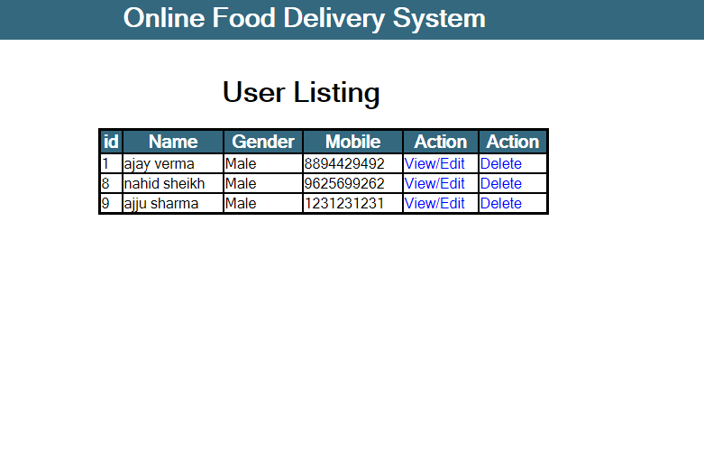

Figure -15

add a new vendor, then supply the name of the vendor and click “Save”. This adds the vendor to the navigation tree on the left. If there will be multiple vendors using the system, repeat this process for each of them. If at any point you would like to modify the vendor names, do so from this screen.

#### Managing Categories

Categories represent a related group of foods, usually what would be found as a menu heading. Categories must be associated with a vendor, so to add a new category select the appropriate vendor from the navigation tree on the left. In the category field, click the “+”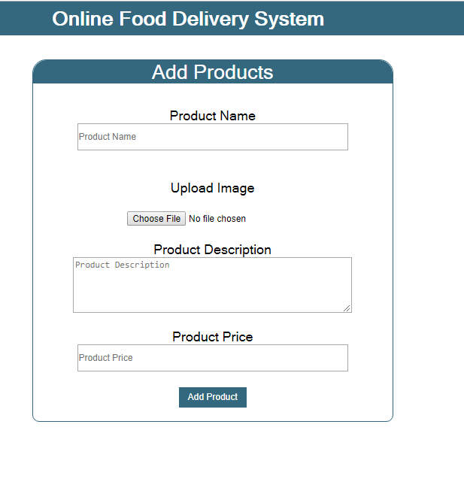

Figure -16

button to add a new category then supply the category name and click “ADD”.

Now select the category you just created from the navigation tree. This will bring up a new form. If items from the category are available in multiple sizes, add these sizes to the “Sizes” field. Some categories allow customers to specify additional options. These options are specified in the “Options” field. Finally, the food items within this category must be added. This is done by clicking the “+” button in the “Food Items” field and supplying the name of the item. When you are finished, click “Save”.

#### Managing Foods

To edit food details, select the food you wish to modify from the navigation tree. From this screen you can now modify the prices and default options for the selected food item. Repeat this process for all items you have added. The ordering system is now ready for use. If at any point you need to edit menu information you can return to these screens through the “Management” tab on the application toolbar.

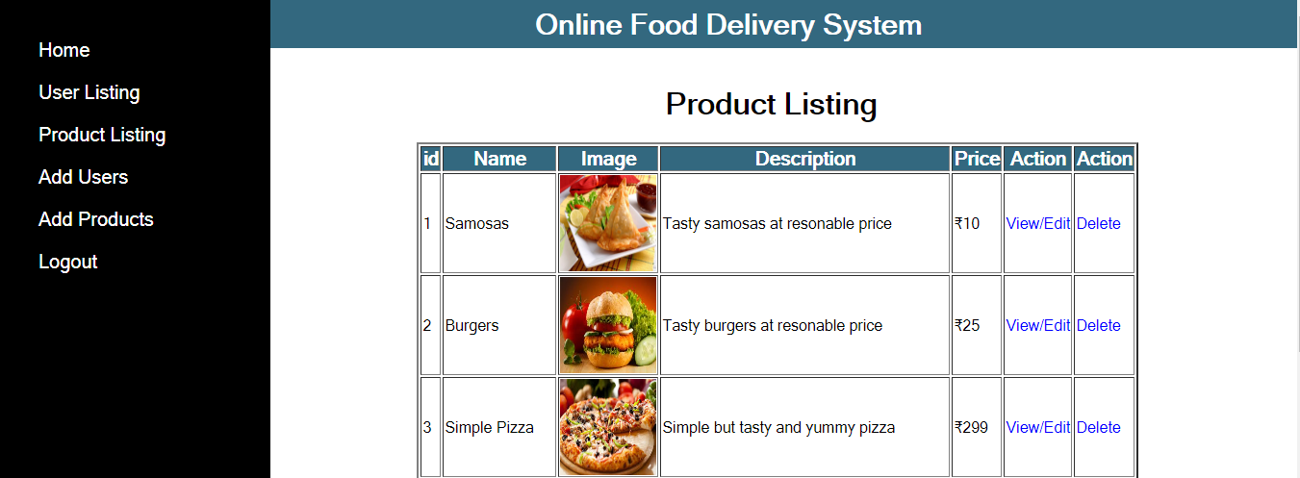

Figure -17

#### Managing Orders

To manage placed orders, navigate to “Orders” > “View Orders” on the application toolbar. You will now see a list of all currently active orders on the left side of the application. To view the details of a specific order, select that order from the list. Once an order has been prepared, mark it as processed by clicking the “Processed” button. As new orders are placed, they will be added to the list of active orders.

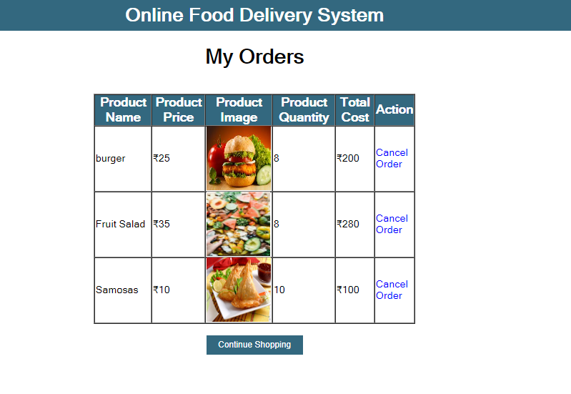

Figure -18

### Using the Web Ordering System

#### Signing Up & Signing In

When a customer first visits the website, they must register before they can begin using the system. To do this, click on the “Sign Up” button on the main page. Then fill out the required fields and click “Register”. An e-mail containing your password will be sent to the specified account and you can then begin using the system.

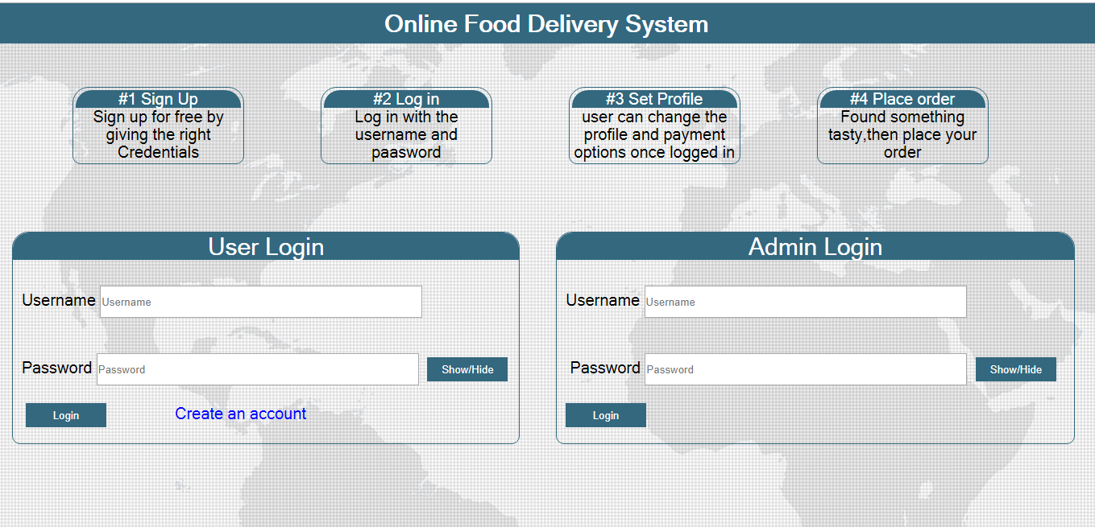

Figure -19

#### Selecting Food Items

After signing in on the main page, click “Check Out Tonight’s Menu…” and select the category of food you would like to order. This will bring up an order form specific to that category.

On this form, select the food you would like to order, specifying the desired size and selecting any appropriate options, then click add to order. This will add the item to your “shopping cart”, located on the far right of the screen. Repeat this process for as many items as you would like to order.

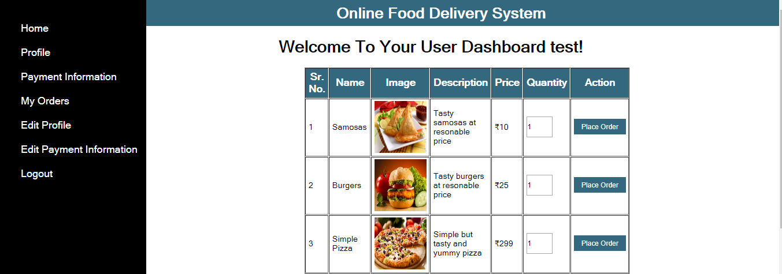

Figure -20

#### Placing an Order

When you are finished adding items to your order, click “Check Out” from within the shopping cart. You will then be presented with one final form to complete. After supplying the required payment and delivery details, click “Place Order”.



Figure -21

You should then receive confirmation that your order was placed successfully, along with your order number, completing the ordering process.

### Using the Help System

The help systems in both the desktop application and online ordering system can be accessed through the “Help” tab on the application toolbar. In both cases, accessing this tab will present the user with a tutorial very similar to those presented above, instructing them, step-by-step, on how to complete the desired action. In addition to this in-application help, the help document for the desktop application will also be distributed with the system as a .pdf to make employee training easier.

Food is a basic need. But then what is the use of travelling a long distance to get the food you need while it is more than possible to order food from where you reside. Living in a technological world where almost everything relies on technology, this technology in the form of ecommerce, not only can it be applied to the buying of goods but also can apply to the food sector, where you are able to order food online using internet either by the computer or phone.

The main justifications for an online order system is to increase efficiency by shortening the purchasing time and eliminating paper work like receipts through online transaction. To be able to stand out from competitors by automating daily operations which will give food service providers the opportunity to increase sales? To reduce restaurants food wastage and increasing efficiency of the restaurants staff by enabling the restaurants staff to know what food items the customers want in advance. To increase customer satisfaction by speeding up food delivery. To reduce time wasting by eliminating long queues. The above benefits and more are discussed below in details.

Using an online food ordering system has many benefits to both the consumer and the business. These benefits include:

1. **Using an online food ordering system is convenient for customers**: Bringing an online food ordering system to customers’ everyday life, makes life much easier for customers. Since they are able to order food from anywhere, home, from work or even if you are stuck in traffic. They do not need to travel long distances. They are able to order food online and get the food delivered to them.
2. **Using an online food ordering system provides the advantage of no misunderstandings or frustrations:** In the sense that if you go online, ‘the line’ is never busy, there is queueing frustration building up so more clients reach out to you during peak times. Moreover, all preferences are specified directly by the customer in the order he or she makes, therefore leaving no room for misunderstandings. This builds up customer loyalty.
3. **An online food ordering system is opened full time:** A restaurant may not be opened full time, day and night. But online there is no reason why such a business cannot be available for every customer. With an online order system, customers can place an order anytime. If it is outside a specific business hour, they can schedule a later pickup or delivery time. As soon as the business is opened, a full list of orders that happened overnight are received for review and acceptance.
4. **For such businesses or restaurants, an online menu is simpler to manage:**It is much easier or cheap or even free to create and maintain a good online menu. There is flexibility in changing the menu as many times as a worker needs. You can easily test different placements of your dishes in the menu, setup daily offerings or handle items with limited availability.
5. **Also an online food ordering system can lead to significant money savings:** For customers, switching from offline food ordering to online ordering means a less hassle on handling undecided calling clients especially on telephone and staff time lost in the process. Moreover, with an ordering food ordering system, no follow up calls are required. The order confirmation is received by the client in real time. There is no cost of ordering itself. The system is free to both the client and the restaurant.
6. **Larger orders and increased sales as opposed to telephone orders:** Restaurant owners and employees often neglect to engage in suggestive selling and upselling when taking telephone orders. With online ordering systems, messages intended to entice customers to try new items, add to their orders, and/or take advantage of special deals are right on the web page in the form of text, images or a combination of the two. In many instances, the end-result is a larger tab.Additionally, online ordering systems let customers take their time in deciding how to augment their orders, pushing the sales envelope even farther unlike in telephone ordering scenarios, where patrons sometimes decline offers just because they have not had enough time to consider them and/or want to end the call.
7. **Ability to build a robust database:** When new customers order online, their names become part of a database that can then be used to create a loyalty program and distribute last-minute, on-the-fly offers to generate business during slow periods or direct attention to new menu items.
8. **Access to powerful analytics:** Online ordering systems also make it easy to track and analyze sales patterns, as well as to determine whether or how customers are responding to discounts and other offers. This information can be used adjust menus, promotions, and the like to better meet customer needs and increase the potential for the business.
9. **Expanded market reach:** Services that connect consumers with the online ordering systems of multiple local restaurants are becoming increasingly popular. Partnering with one of these services makes it easier to attract customers who may not otherwise have known about your establishment and its offerings.
10. **Enhanced order accuracy as opposed to telephone orders:** Miscommunications and misunderstandings between customers and the employees who are recording their telephone orders are very common, especially at establishments with language barriers. These lead to food preparation errors. Online ordering allows orders to be electronically transmitted directly to the kitchen, eliminating food preparation inaccuracies that come from such miscommunications as well as the costly, time-consuming process of re-making each dish as directed and delivering the replacement to the customer. What’s more, with printouts of online orders in hand, restaurants need not assume responsibility should a customer claim that food was not prepared as requested or that an item that was ordered was not delivered. This also saves restaurant owners time and money.

Above are the benefits of using the online order system. And below is the representation of the UML and DFD diagram respectively

\

1. UML DIAGRAM.

 Figure -22

2. DATA FLOW DIAGRAM



Figure -21

**SYSTEM TESTING**

**Project Implementation & Testing**

At the end of the system design, it is the beginning for the actual coding to develop the proposed system. During development phase, the table structure of the database will be first built in order to provide a suitable data types that suit the system back end development, system connection and data transfer. Next, the computer side client program will be developed and follow by will be the web services that allow mobile phone client program to communicate with the server and lastly mobile phone side client program will be developed. In testing phase, several test cases will be carry out to test the system in order to determine the system reliability and system accuracy. According to the test cases, a system testing report will be generated for further review to figure out the system weaknesses and made improvement accordingly. In the deployment phase, several training will be provided for the particular restaurant staff such as how to operate the system, the procedure of handling different event and several instruction that need to be follow when operating the system.

**Implementation Issues & Challenges**

During the system implementation phase, several challenges need to be confront because it involve end users to test the production system with various situation. The possible challenges may face are as following:

**User without background**

The users are required to have basic knowledge of how to operate a computer system and android mobile phone in order to use the system. This will be difficulty to give training to the user as the basic knowledge information can be obtained from internet easily.

**The screen size of different device**

This would be one of the issue that will encounter while implementing the system. Because user are able to download the mobile application from the official website and use it as a client device to place order. Therefore, if the user device screens size are too small or too big. The content and interface of the application may not consistence.

**Server performance**

During real time system implementation, three would be a huge number of client that access to the server at the same time. Therefore, it may slow down the connection and performances of the system and even causes the server down if the issue goes beyond the level of acceptance.

**Development Tools**

**Database Environment**

The proposed system will need a database system to support in order to store the huge amount of data. MySQL database system will be chosen to support the proposed system because it is well-known open source relational database management system. Other than that, MySQL database system provides software developer with a client program with easy understanding graphical user interface that can communicate to the MySQL database server named as MySQL Workbench 6.3 CE. By doing so, software developer can interact with the database system with the user friendliness client program and without using the command prompt, at the end it may speed up the development progress.

**Web Technology**

The proposed system is a cross platform system, which include Windows desktop client and Android mobile phone client. Therefore, it require to implement web services in order to support the Android mobile phone client device to fetch data from the database server and store data back to the database server. In this project, WampServer is used to support the issue that mention earlier. WampServer is a Windows web development environment that built-in comes together with the Apache, PHP and MySQL database. Furthermore, PHP will be the programming language that used to create the web services that store in the server and it is able to call by the Android mobile phone client to perform particular task.

**System Platform**

The project is a cross platform based system which includes Windows desktop client device and Android mobile phone client device in order to operate the proposed system

software. Therefore, IOS mobile phone client device will not compatible with the proposed system.

**Project Management Tool**

For the rule of thumb to develop a system, it requires to have an intact system planning which serve as a guide line during the development phases. Microsoft Project is a project management software program and it has been used in the project to design the system planning, project timeline, managing of resources, tracking development progress and etc.

**Test Plan**

After the system has been developed, it will move to system testing phase. In system testing phase, the developed system is required to install on appropriate devices for testing purpose. After the system installation has been completed, the system testing task will be performed by different roles of user such as manager role and staff role. The purpose of system testing is to identify and determine the degree of system stability. At the same time, it is given an opportunity for developer to figure out error or bug that has not been raise and encounter during the system development phase. Those error or bug that has been found during the system testing activities will be solved before the system release. Each and every testing before system testing phases is actually tested by the system developer itself. Therefore, it might cause some biases toward the testing due to the system developer have knowledge about the system software logics and lead the result to be inappropriate. There are four types of testing that will be used to test the developed system which includes unit testing, integration testing, system testing and acceptance testing.

**Unit Testing**

First of all, unit testing will be the first testing method that used to test the developed system. It consists of testing activities that test the system module by module which has not been integrated as a whole. By doing unit testing, developer are able to identify error and bug easily since it is finding the error and bug through a unit part of the system rather than finding error through the complete system. In addition, developer will test the unit part of the system with the validation and the correctness of data value. Valid and invalid input will be entering to test and ensure the system processes perform with an expected result.

**Login as system user**

**Testing Objective:** To ensure user can login into system correctly with valid ID andpassword.

|  |  |  |  |  |  |
| --- | --- | --- | --- | --- | --- |
| **No** | **Event** | **Attribute and Value** | **Expected Result** |  | **Result** |
|  |  |  |  |  |  |
| 1 | Verify that ID and password | Login ID: validID | Login successfully. |  | Pass |
|  | that enter by user and match | Password: validPassword |  |  |  |
|  | the data in the database |  |  |  |  |
|  | when user click “OK” |  |  |  |  |
|  | button on the login prompt. |  |  |  |  |
|  |  |  |  |  |  |
| 2 | Verify the invalid ID and | Login ID: validID | Login failed and |  | Pass |
|  | password that enter by user | Password: invalidPassword | prompt out the error | |  |
|  | and match with the data that | OR | message to user. |  |  |
|  | store in database when user | Login ID: invalidID |  |  |  |
|  | click “OK” button on the | Password: validPassword |  |  |  |
|  | login prompt. |  |  |  |  |
|  |  |  |  |  |  |
| 3 | Verify the situation that user | Login ID: null | Login failed and |  | Pass |
|  | does not enter any value into both ID and password | Password: null | prompt out the error | |  |
|  |  | Message to user. |  |  |  |
|  | | | |  |  |

**Create new system user**

**Testing Objective:** To ensure new user can be created properly.

|  |  |  |  |  |
| --- | --- | --- | --- | --- |
| **No** | **Event** | **Attribute and Value** | **Expected Result** | **Result** |
|  |  |  |  |  |
| 1 | Create new system user. | System user information. | Prompt new user has | Pass |
|  |  |  | been created |  |
|  |  |  | successfully message. |  |
|  |  |  |  |  |
| 2 | Create new system user | All blank field. | Prompt require field | Pass |
|  | without entering any |  | error message. |  |
|  | information. |  |  |  |
|  |  |  |  |  |
| 3 | Create new system user | Enter duplicated staff | Prompt error message | Pass |
|  | with duplicated staff | number and click create | indicate that |  |
|  | number. | new user. | particular field has |  |
|  |  |  | duplicated. |  |
|  |  |  |  |  |
| 4 | Create new system user that | System user information | Prompt require field | Pass |
|  | has at least one or more | with some field leave | error message. |  |
|  | field that is leave blank. | blank. |  |  |
|  |  |  |  |  |
| 5 | Update existing system user | Edit and replace the system | Successfully updated | Pass |
|  | information. | user details. Eg: Name: | system user details |  |
|  | into system. |  |
|  |  |  |  |
|  |  | Carson to Name: Carson |  |  |
|  |  | Leong |  |  |
|  |  |  |  |  |

**Add new food category to the menu**

**Testing Objective:** To ensure manager add new food category into the system properly.

|  |  |  |  |  |
| --- | --- | --- | --- | --- |
| **No** | **Event** | **Attribute and Value** | **Expected Result** | **Result** |
|  |  |  |  |  |
| 1 | Manager enters the category | Food Category Name: | The entered category | Pass |
|  | name and click “OK” | Soup | name is store into the |  |
|  | button. |  | database and |  |
|  |  |  | refreshes the food |  |
|  |  |  | category panel with |  |
|  |  |  | the new added |  |
|  |  |  | category. |  |
|  |  |  |  |  |
| 2 | Manager leaves the category | Field is blank. | System will detect it | Pass |
|  | name blank and click “OK” |  | is null value and |  |
|  | button. |  | prompt error |  |
|  |  |  | message. |  |
|  |  |  |  |  |
| 3 | Manager enters duplicated | Food Category Name: soup | Prompt error message | Pass |
|  | food category name and | Or | indicate that |  |
|  | click “OK” button. | Food Category Name: | duplicated food |  |
|  |  | Soup | category has been |  |
|  |  |  | detected. |  |
|  |  |  |  |  |

**Add new food to the menu**

**Testing Objective:** To ensure manager add new food into the system properly.

|  |  |  |  |  |
| --- | --- | --- | --- | --- |
| **No** | **Event** | **Attribute and Value** | **Expected Result** | **Result** |
|  |  |  |  |  |
| 1 | Manager enters all valid | Food Code: S002 | The entered food | Pass |
|  | food information and | Food Name: Mushroom Soup | information is store |  |
|  | chooses an image that | Price(RM):12 | into the database and |  |
|  | represents that food and | Food Availability: Yes | refreshes the food |  |
|  | click “Add” button. |  | menu panel with the |  |
|  |  |  | new added food. |  |
|  |  |  |  |  |
| 2 | Manager leaves the food | Field is blank. | System will detect it | Pass |
|  | information blank and |  | is null value and |  |
|  | click “Add” button. |  | prompt error |  |
|  |  |  | message. |  |
|  |  |  |  |  |
| 3 | Manager leaves some | Food Code: | System will detect it | Pass |
|  | required field to blank | Food Name: Mushroom Soup | is null value and |  |
|  | and click “Add” button. | Price(RM): | prompt error |  |
|  |  | Food Availability: Yes | message. |  |
|  |  |  |  |  |
| 4 | Update existing food | Edit and replace the current | Successfully updated | Pass |
|  | information. | details. Eg: Food Price(RM): | food information into |  |
|  | system. |  |
|  |  |  |  |
|  |  | 25.00 to Food Price(RM): |  |  |
|  |  | 30.00. |  |  |
|  |  |  |  |  |

**Make reservation for customer**

**Testing Objective:** To ensure user can make reservation and store into the systemproperly.

|  |  |  |  |  |  |
| --- | --- | --- | --- | --- | --- |
| **No** | **Event** | **Attribute and Value** | **Expected Result** |  | **Result** |
|  |  |  |  |  |  |
| 1 | Staff enters all the | Customer Name: Carson | The entered |  | Pass |
|  | reservation information | Pax: 5 | reservation |  |  |
|  | and click “Save” button. | Date: 02 – 13 -2016 | information is store |  |  |
|  |  |  |  |  |  |

**Payment for the ordered items**

**Testing Objective:** To ensure payment make by customer working properly.

|  |  |  |  |  |  |
| --- | --- | --- | --- | --- | --- |
| **No** | **Event** | **Attribute and Value** | **Expected Result** |  | **Result** |
|  |  |  |  |  |  |
| 1 | Verify food order record | Food information and taxes | Display all food |  | Pass |
|  | belong to which table and | information. | information that |  |  |
|  | calculate the amount. |  | belong to the table and | |  |
|  |  |  | calculated correct |  |  |
|  |  |  | price amount. |  |  |
|  |  |  |  |  |  |
| 2 | Verify the price | Subtotal: RM10 | Store data into |  | Pass |
|  | calculation is correct. | Service Tax(10%): RM1 | database and back to | |  |
|  | the open sales |  |  |
|  |  |  |  |  |
|  |  | GST Tax(6%): RM0.60 | interface. |  |  |
|  |  | Grand Total: RM11.60 |  |  |  |
|  |  | Amount Receive(RM): |  |  |  |
|  |  | RM15.00 |  |  |  |
|  |  | Changes(RM): RM3.40 |  |  |  |
|  |  |  |  |  |  |
| 3 | Verify the cash amount | Subtotal: RM10 | Payment cannot be |  | Pass |
|  | receive from customer | Service Tax(10%): RM1 | make if the amount |  |  |
|  | receives from |  |  |
|  |  |  |  |  |
|  | must more than or equal | GST Tax(6%): RM0.60 | customer is less than | |  |
|  | to the grand total | Grand Total: RM11.60 | the grand total |  |  |
|  | amount. |  |  |
|  |  |  |  |  |
|  | amount. | Amount Receive(RM): 10.00 |  |  |  |
|  |  |  |  |  |  |
|  | | |  |  |  |
|  | | | |  |  |

**Functional Testing**

After conducted the unit testing, functional testing will begin to test the developed system. Functional testing is performed to verify that the system application processes that perform and functioning appropriately according to the design specifications. In functional testing, the core system application functions will be tested with several test cases in order to ensure that the entire system functioning as a whole and perform task that with the expected results.

**Login with different user role**

**Testing Objective:** To ensure user with different role login according to restrictedsystem features.

|  |  |  |  |  |
| --- | --- | --- | --- | --- |
| **No** | **Event** | **Attribute and Value** | **Expected Result** | **Result** |
|  |  |  |  |  |
| 1 | Login as “Staff” | Login with Normal staff | Successfully login. | Pass |
|  |  | information |  |  |
|  |  |  |  |  |
| 2 | Login as “Manager” | Login with manager | Successfully login. | Pass |
|  |  | information |  |  |
|  |  |  |  |  |

**Place order by staff using computer and by customer using mobile phone**

**Testing Objective:** To ensure order place by staff is stored to the system and workproperly

|  |  |  |  |  |  |  |  |
| --- | --- | --- | --- | --- | --- | --- | --- |
| **No** | **Event** | **Attribute and Value** | | **Expected Result** | | | **Result** |
| 1 | Place order according to  what customer request | Food Quantity and extra remark  for that particular food. | | Order details  submitted successfully and store into the  database system. | | | Pass |
| 2 | Edit or void order detail | Edited food quantity or void | | Cancel the order | | | Pass |
|  | before the order being | the ordered item. | | process and redirect | | |  |
|  | submitted |  | | back to open sales | | |  |
|  |  |  | | interface. | | |  |
|  |  |  | |  | | |  |
| 3 | Edit or void ordered | Change order quantity with | | Voided order will | | | Pass |
|  | item after order has been | valid reason. Eg: From 2 units | | update immediately | | |  |
|  | submitted. | to 1 unit and reason is | | and void log will store | | |  |
|  |  | “Customer Request”. | | to the database. | | |  |
|  |  | Or | |  | | |  |
|  |  | Void the ordered item with | |  | | |  |
|  |  | valid reason. Eg: Cancel the | |  | | |  |
|  |  | entire order of the particular | |  | | |  |
|  |  | item and reason is “Out of | |  | | |  |
|  |  | Stock”. | |  | | |  |
|  |  |  | |  | | |  |
| 4 | Customer used their | Selected table and selected | | Order details | | | Pass |
|  | own device or restaurant | food order quantity. | | submitted through | | |  |
|  | prepared devices that |  | | mobile phone to | | |  |
|  | installed with the mobile |  | | database system | | |  |
|  | application to place |  | | successfully. | | |  |
|  |  | |  | | |  |
|  |  |  | |  | | |  |
|  | | |  | |  |  | | |
|  | | | | |  |  | | |

**Update menu information**

**Testing Objective:** To ensure the menu information is updated and works properly.

|  |  |  |  |  |  |
| --- | --- | --- | --- | --- | --- |
| **No** | **Event** | **Attribute and Value** | **Expected Result** |  | **Result** |
|  |  |  |  |  |  |
| 1 | Manager intends to | Food Availability: Yes | The particular food will |  | Pass |
|  | update the food | Or | disappear from the food |  |  |
|  | availability due to the | Food Availability: No | order interface both desktop | |  |
|  | fresh ingredient |  | client and mobile phone |  |  |
|  | shortage. |  | client devices according to | |  |
|  |  |  | the food availability. |  |  |
|  |  |  |  |  |  |
| 2 | Manager intends to | Change the food price to | Updated food information |  | Pass |
|  | update the food | the current updated | will store into the database | |  |
|  | information with the | pricing. Eg: Edit | and the updated information | |  |
|  | latest information. | selected food price from | will reflect to the food order | |  |
|  |  | RM10.00 to RM15.00. | interface for both desktop |  |  |
|  |  |  | client and mobile phone |  |  |
|  |  |  | client devices. |  |  |
|  |  |  |  | |  |
| 3 | Manager intends to add | Food Code: | New food information will | | Pass |
|  | new food item that able | NewFoodCode | store into the database and | |  |
|  | to serve customer. | Food Name: NewFood | the latest food information | |  |
|  |  | Price(RM):12.00 | will reflect to the food order | |  |
|  |  |  |  |  |  |
|  | | |  |  |  |
|  | | | |  |  |

**Generate report**

**Testing Objective:** To ensure the report is generated appropriately.

|  |  |  |  |  |  |
| --- | --- | --- | --- | --- | --- |
| **No** | **Event** | **Attribute and Value** | **Expected Result** |  | **Result** |
|  |  |  |  |  |  |
| 1 | Login as manager. | Manager login | Login successfully and |  | Pass |
|  |  | information. | display report type |  |  |
|  |  |  | interface. |  |  |
|  |  |  |  | |  |
| 2 | Manager generates daily | Select the specific date | A PDF file daily sales report | | Pass |
|  | sales report at the end of | to generate the selected | will generated according to | |  |
|  | the day. | date daily sales report. | the selected date with its |  |  |
|  |  |  | records. If the selected date | |  |
|  |  |  | has no record found from |  |  |
|  |  |  | the database, it will prompt | |  |
|  |  |  | a notification indicate user. | |  |
|  |  |  |  | |  |
| 3 | Manager generates daily | Select the specific date | A PDF file daily order void | | Pass |
|  | order void report at the | to generate the selected | report will generated |  |  |
|  | end of the day. | date order void report. | according to the selected |  |  |
|  |  |  | date with its records. If the | |  |
|  |  |  | selected date has no record | |  |
|  |  |  | found from the database, it | |  |
|  |  |  | will prompt a notification |  |  |
|  |  |  | indicate user. |  |  |
|  |  |  |  |  |  |
| 4 | Manager generates | Select the specific year | A PDF file monthly sales |  | Pass |
|  | monthly sales report at | and specific month to | report will generated |  |  |
|  | the end of the day. | generate the monthly | according to the selected |  |  |
|  |  | sales report. | year and month with its |  |  |
|  |  |  | records. If no record found | |  |
|  |  |  | from the database, it will |  |  |
|  |  |  | prompt a notification |  |  |
|  |  |  | indicate user. |  |  |
|  |  |  |  | |  |

**Update Order through Kitchen Dashboard**

**Testing Objective:** To ensure the order queue and order status is updated and reflects tothe open sales interface.

|  |  |  |  |  |
| --- | --- | --- | --- | --- |
| **No** | **Event** | **Attribute and Value** | **Expected Result** | **Result** |
|  |  |  |  |  |
| 1 | Kitchen staff updates the | Information of the selected | The selected order | Pass |
|  | order status when it is | order. | status is updated and |  |
|  | preparing to be served. |  | reflects to the open |  |
|  |  |  | sales interface and it |  |
|  |  |  | is no longer able to |  |
|  |  |  | be void. |  |
|  |  |  |  |  |
| 2 | New order that are | New order information that are | The order queue will | Pass |
|  | placed and submitted to | placed. | automatically refresh |  |
|  | the system. |  | with the new order |  |
|  |  |  | that are placed. |  |
|  |  |  |  |  |

**Acceptance Testing**

Last but not lease, acceptance testing also known as user acceptance testing would be the final testing procedure that perform to test the developed software system. In acceptance testing, the testing activities are different compare to the testing activities that mentioned previously because the tester that tests the system will be the final user which do not have knowledge about the system logic. If the final user encountered an error while using the system, system developer are required to maintain the system as soon as possible and release a new patch for the existing system to recover the error. Meanwhile, final user will use the system that visualized as to support their real business routine operation, therefore software support team are required to stand by to provide technical support while final user need any help or support that regarding the system. If there is no errors detected by the final user while using the system for a long period, the development job of developer is consider as complete and the system will be a final system product.

**System Testing**

System testing of the software and hardware is a testing conducted on a system which is complete, integrated system that works as a whole. System testing is a critical testing procedure that must be conducted by software developer before the system released. During system testing it can evaluate the system’s compliance with its specified requirements according to the system design. Furthermore, several testing activities in system testing test not only the design of the system, but also the behavior and the believed expectations result from the customer. In addition, various complex test cases that used to test the system are according to the business process requirements which are collected from the user. Meanwhile, errors or bugs that detected during the testing is required software developer look into it from the initial step of the business process to the end of the process to ensure it have expected result in order to solve the errors or bugs to determine the degree of system stability.

**CONCLUSION**

The development of online food ordering system involved many phases. The approach used is a top-down one concentrating on *what* first, then *how* and moving to successive levels of details.

The first phase started with a detailed study of the problems and prospects of ordering in Krispy Foods, Awka. In the course of this study, many problems were discovered to have hindered the effectiveness of the existing manual system. These problems, information needs and activities were documented and later used as the basis for system design, which immediately followed the first phase. The design phase was concerned primarily with the specification of the system elements in manner that best met the organization’s business needs.

During this phase, strict adherence was made on proven software engineering principles and practices. To implement this design, a computer program was then written and tested in phpMyadmin environment.

It is hoped that effective implementation of this software product would eliminate many problems discovered during systems investigation.

**RECOMMENDATIONS**

It is known that for any meaningful computer based information management to be integrated into any organization, proper training and orientation has to be given both to the staff and management. Proper training should be given to the data entry staff on how to handle the computer hardware especially during backup processes. In particular, electronic storage media are usually sensitive to change in temperature or pressure and as such, data can be lost very easily. The staff should also be highlighted on the need and advantage of the system and how it will equally assist them in their various field of work. They should also be informed of the cost of maintaining this new system so that they will handle it with all carefulness. Training materials should not be presented in formal way but with procedures like policies and form etc, they should be circulated to the personnel. This will at the end generate appreciation and needed interest to operate the system.

**REFERENCES**

Anderson, R.G. (1978), “*Data processing and Management Information* *Systems*”McDonald and Evans Ltd.

Bhatnagar, P.

(2006, march 28). *Dinning Trends: self service=Quick-service.*

Brickers, J.

(2006, July 24). *Is Fast Casual Self-Service at the Tripping* *Ponit?*

De Leon, E.

(2008, August 23*).*

*Best*

*Online*

*Food*

*Ordering*

*System.*

*Restaurant Checklist.*

Gan, C.C.

Hobbs, N.

Kroc, Ray

(2002). *Online Fast Food Restaurant Ordering Systems*

(2004, march 26). *Restaurant Customer Ordering.*

(1977). *Grinding it out: The Making of McDonald’s.* Chicago:

Contemporary Books.